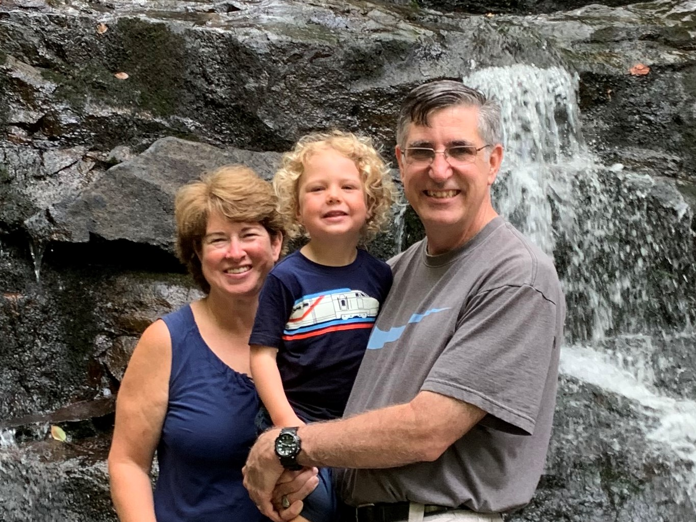

Kirk Streitmater
5817 Oakland Park Drive, Burke VA 22015
571-577-7517 | streitmaterk@verizon.net

Ministry Philosophy
My wife of 28 years and I live in Burke, VA just outside of Washington DC. My passion for ministry has been teaching a men’s bible study and apologetics. I’ve recently undertaken a role to build up a grandparent ministry at the church with the mission of Enabling senior saints to build, equip, teach and encourage the future generations of believers and leaders for the Kingdom of God.

Personal Summary
- Raised in New Hampshire, I spent my first 18 years in New England and became a very active fan of the Red Sox, Patriots, Bruins and Celtics.
- I accepted Christ as a sophomore in high school from the witness of a pastor/mechanic named Andy who had a heart for young men.
- Attended the Air Force Academy and graduated in 1986. Served as a program manager and major weapon system officer during a 20 year career that culminated in six years at the Pentagon.
- A short paragraph on your conversion experience (include date) and how God called you into ministry
- I am married to the former, Mary Raisch, who was born to missionary family in Haiti and grew up in the Christian and Missionary Alliance church in Dayton, OH. My son Alex is 26 and serves as a youth pastor in Annapolis, MD. My daughter lives locally with my only grandson, Percy—a spunky 3-year-old boy.
- Mary and I enjoy walking, going to Red Sox baseball games and traveling to warmer climates when at all possible.

Education
Air Force Institute of Technology, Wright-Patterson AFB, OH
- Masters of Science in Systems Management, 1991
United States Air Force Academy, Colorado Spring, CO
- Bachelors of Science in Astronautical Engineering, 1986
Dallas Theological Seminary, Dallas, TX
- Masters of Arts in Christian Leadership, in progress

Ministry Experience
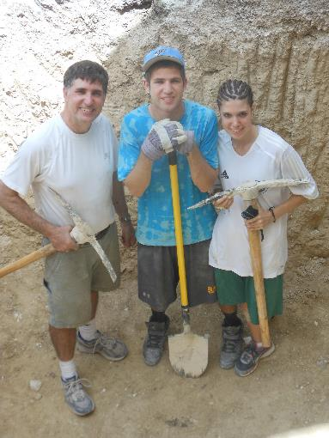
My passion for ministry has involved teaching God’s word and the study of apologetics (1 Peter 3:15). I’ve been involved in youth and junior high ministries during while raising my children. More recently, For the last 10 years, I’ve been involved in men’s ministry and team teaching a large adult bible study. For several years I was also active as part of a service team traveling to Haiti with of a non-profit organization called Servants for Haiti (www.servantsforhaiti.org). Servants for Haiti was founded in 2005 following several years of involvement with missions work to that country.
Roles supporting the ministry included:
- Adult Bible Fellowship Teacher
- Immanuel instructor and Power User for Logos Bible Software
- Immanuel instructor for online biblical and apologetic resources
- Men’s Groups Small Group Leader
- Men’s Group Large Group Speaker
- Junior High Speaker on the Topic of Faith and Apologetics
- Assistant Scout Master and Merit Badge Counselor for Immanuel’s Troop 1115
I have taken a partial leave to focus on my initial studies at DTS and build up a balance between work, school and personal commitments. My near term focus is the development of an Immanuel Bible Institute course on Grandparent Ministry. This also serves as a long term focus for my ministry to the Gospel.

Publications
- Hagiazo.net (a personal ministry page and teaching website)

References

Tom Joyce  Pastor  Pastor of Next Generation, Discipleship and Family  Joyce@ibc.church  703-941-1220 | Bob Hartman  Pastor  Pastor of Adult Education and Groups  hartman@ibc.church  703-941-1220
Eric Long, PhD
Supervisor
Vice President, Chief Technology Officer
long-eric@zai.com
303-739-8314

