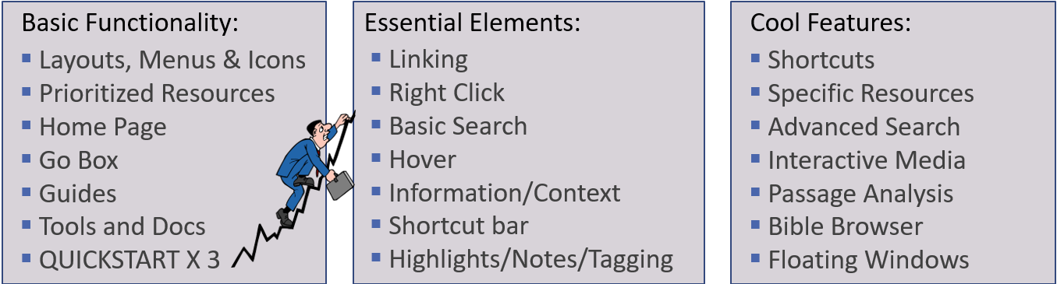

Review Basic Functionality
- Instrument Panel Top 4: Factbook, GO BOX, Shortcuts Bar, Layout Menu
- Resource Panel Toolbar: Sidebar, Visual Filters, parallel resource sets, panel history

Review the Panel Menu

- Linking your Panels
  - Linking Bibles, Commentaries, Dictionaries and Lexicons
  - Link Your Books Together | Logos Bible Software - YouTube

Context Menu – Selectable Menus at your Fingertips
- This is by far the easiest way to navigate Logos
  - Make a selection on the left panel and

Basic Search Features - Logos 9 Search - YouTube by Kirk
- Panel Search is the MAJOR search capability accessed via Context Menu or
  - Bible – Search elements of your bible (or bible library)
  - Basic – Search most everything else to include library, tagged items, collections
- Inline Search is the search feature available for a specific resource

The Selection Menu – This will pop up when you select text
- Big 3: Passage Guide, Exegetical Guide, Bible Word Study

The Art of Hovering – Most of the Icons will display their title when you hove over them
  - Emphasize Active References - Faithlife TV
  - Bible Browser Quicklook

Shortcuts
- Toolbar Shortcuts | Logos Bible Software - YouTube

Notes
- Notes Tool | Logos Bible Software Support - YouTube
- Inductive Bible Study

Search Panel Examples (Bible Reference Range + Bible Library Scope)
- English Word Search: “worry” – Gospels – Open Bible; “avoid” – New Testament – top bibles
- Context Search of a word: John 1:18 (exegeomai)
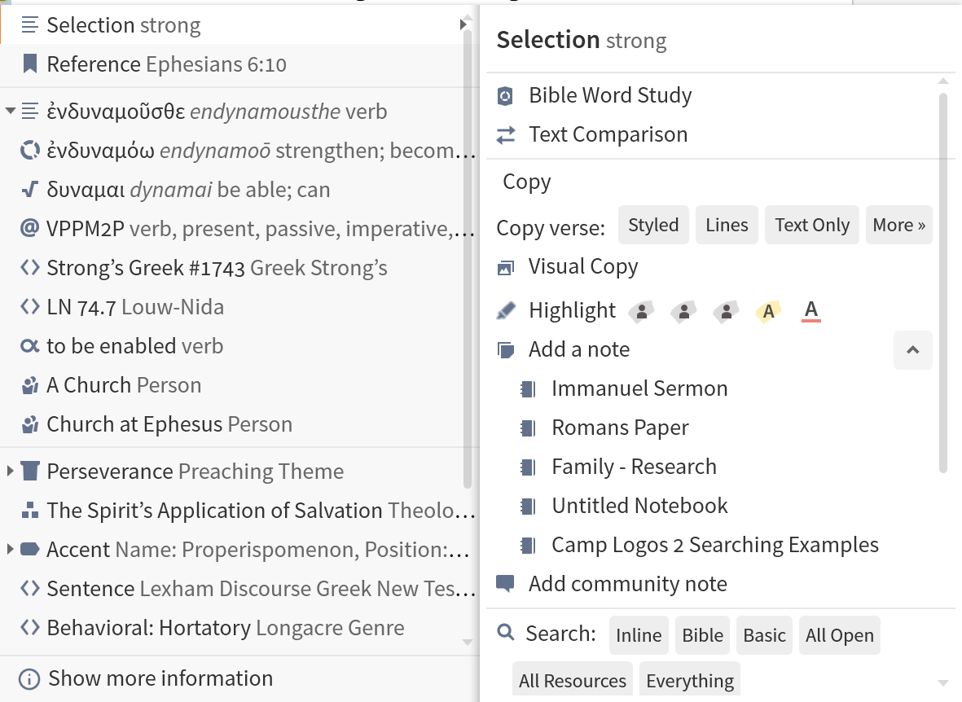
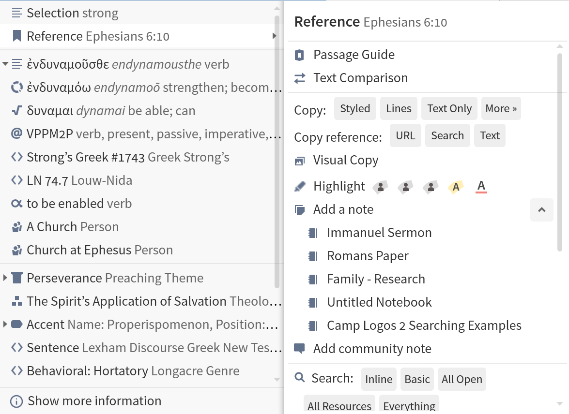
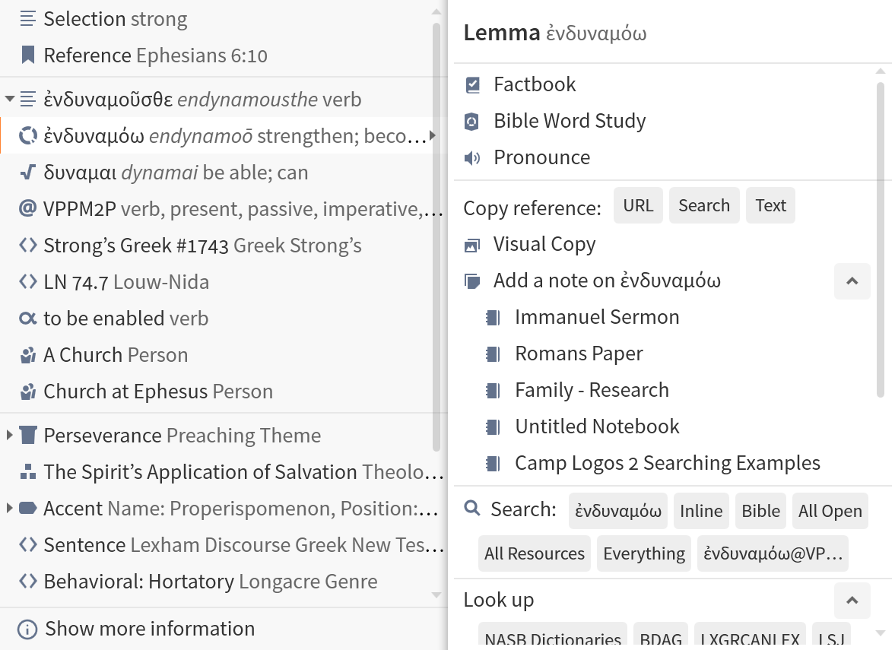
Selection Options
Search Panel
Notes
Highlighter
Three Selection Options

