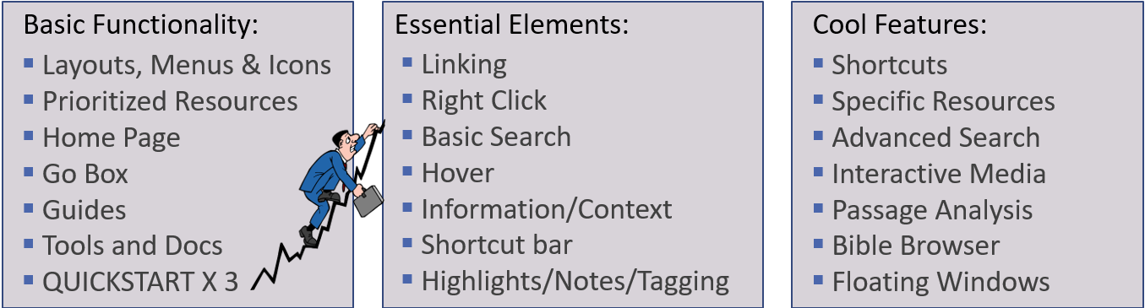

Shortcuts - Toolbar Shortcuts | Logos Bible Software - YouTube
- Instrument Panel Top 4: Factbook, GO BOX, Shortcuts Bar, Layout Menu

- Resource Panel Toolbar: Sidebar, Visual Filters, parallel resource sets, panel history

Notes
- Notes Tool | Logos Bible Software Support - YouTube
- Search And Organize Your Notes - Faithlife TV

Highlighting
- Using Highlights - Faithlife TV

Searching a Topic - Study A Topic - Faithlife TV

Advanced Search Features - Introduction to Searching - YouTube

Specific Resources
- Best Commentaries | Old and New Testament Bible Commentary reviews, ratings, and prices
- The New Moody Atlas of the Bible
- Handbook to Prayer
- Exploring Christian Theology

Other Features
- Notes & Highlights
- The Bible Browser (online feature) – Access to Tags and Facets
- Interactive Media Options
- Big 3: Passage Guide, Exegetical Guide, Bible Word Study
- Floating Windows
- Timeline
- Weights and Measures
- Psalms Explorer
- Free Book of the Month from Faithlife Ebooks

